Thank you for ordering a made to measure Suit from The Jet Luge Cowboy. To make sure we get it right for you please double check your measurements. They should be taken in centimetres, take the measurements loosely from your body. If you are not sure about anything, please contact me. You can print this form and write your measurements below or you can email them to dazthecowboy@hotmail.com
(SIZES SHOWN ARE ONLY FOR EXAMPLE) please put your size in it’s place.
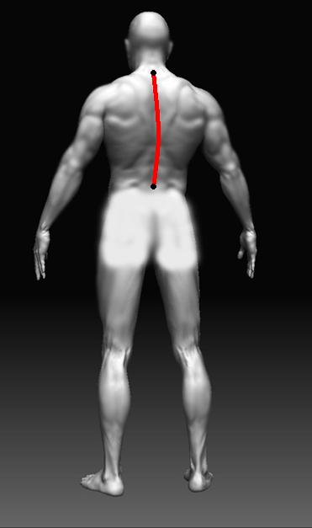
1 - Back Length
Measure from the bone at the
top of your spine (base of your neck)
to your waist belt line. This is where the bottom
of the stretch panel will be made.

51cm

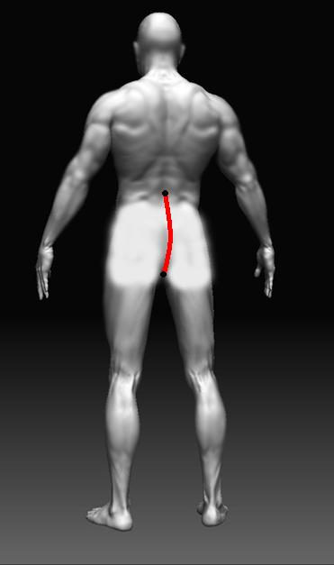

2 - Waist to Crotch Back
Measure from your waist belt line to
The backside of your crotch

27cm

3 - Neck to Crotch back
Measure from the bone on your spine at
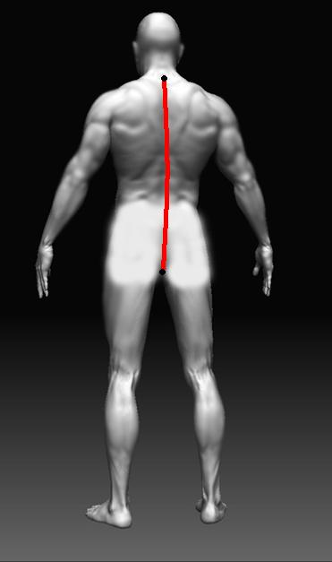
the base of your neck to the backside of
your crotch
Measurements A + B should add up to this
measurement, please do not proceed until
they do

78

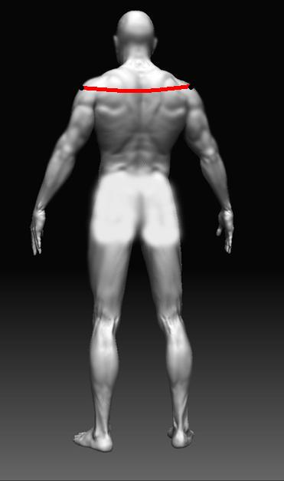
4 - Cross Shoulders
Measure from the centre tip of one shoulder, across
the top of your back to the centre of the tip of your
other shoulder

51cm

5 - Shoulder Slope
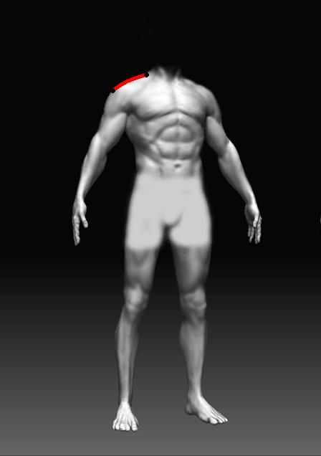
Measure from the base of one shoulder slope
to the tip of your same shoulder

16cm

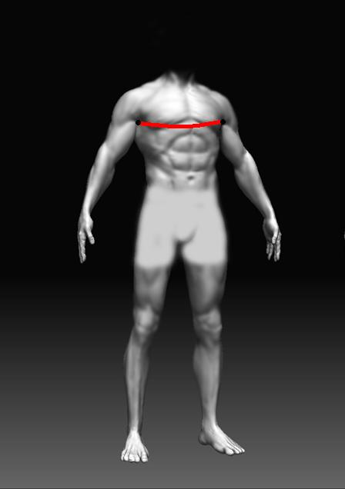
6 - Chest
Measure loosely all the way around your chest,
across your back, underneath your armpits
at the widest point. Take the measurement when
breathing out.

100cm
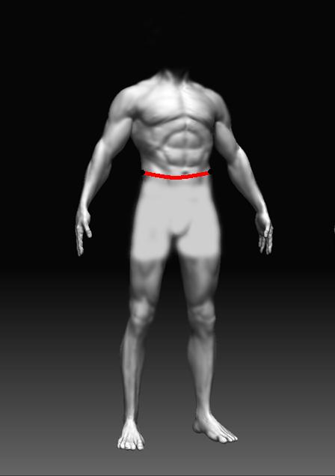

7 - Waist
Measure loosely all the way around your waist at the
widest point. Take the measurement while breathing
out

86cm

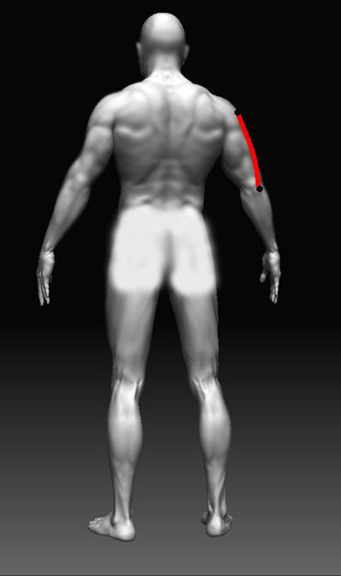

8 - Shoulder to Elbow
Measure from the tip of your shoulder to the
tip of your elbow on one arm. Keep your arm bent
at 90 degrees.

37cm

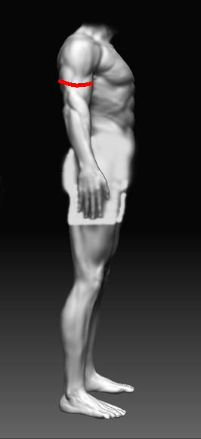
9 - Biceps
Measure loosely all the way around the top of
your arm or your bicep when tensed.

33cm

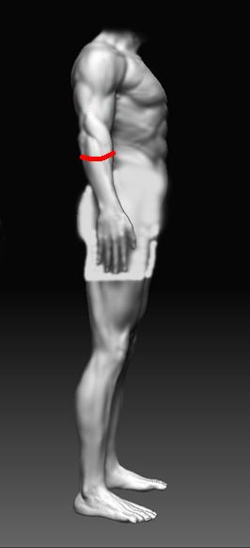
10 - Forearms
Measure loosely all the way around the top
of your forearm when tensed.

31cm

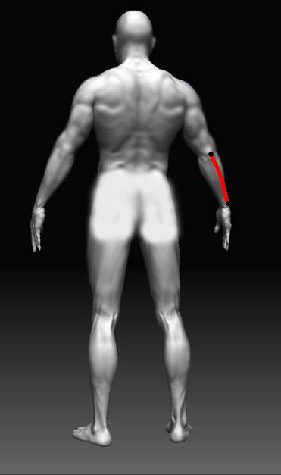
11 - Wrist to Elbow
Measure from the tip of your elbow to the
furthest point of your wrist most prominent bone
(just before it meets your hand)
24.5cm

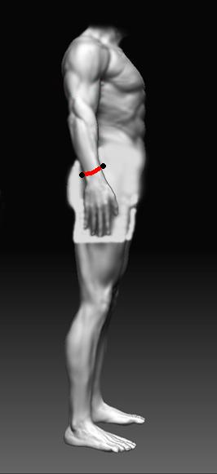
12 - Wrist
Measure loosely all the way around your wrist

17cm

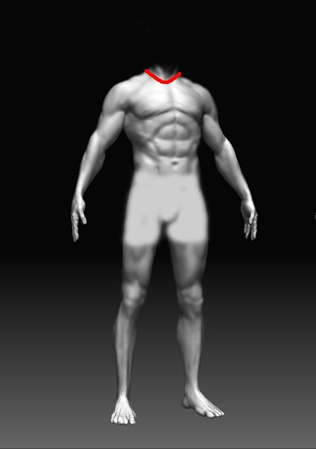
13 - Collar
Measure loosely all the way around the
bottom of your neck as low as you can go.

43cm

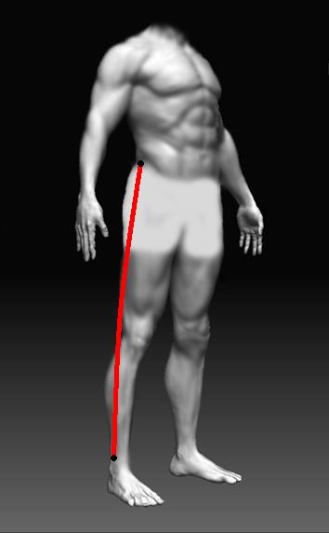
14 - Outside Leg
Measure from the top of your hip bone
(usually above your waist belt line) to your ankle,
just above the ball ankle bone

96cm

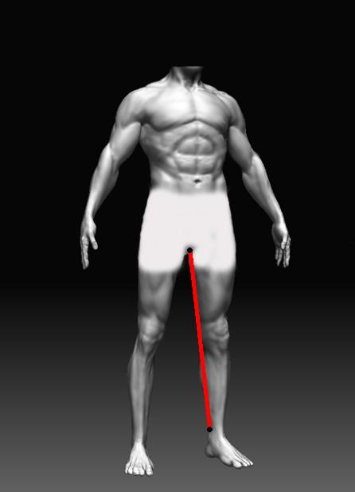
15 - Inside Leg
Measure from the inside of your groin as high
as you can to the same point on your ankle
as your outside leg on the other side,

74cm
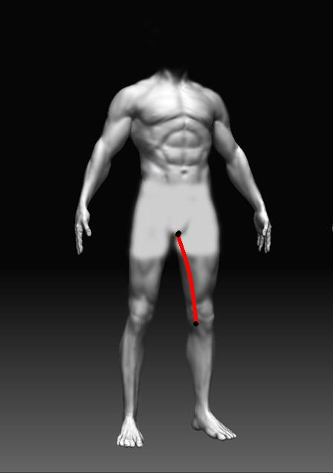

16 - Crotch to Knee
Measure from the inside of your crotch
to the centre of your kneecap, keep your
knee slightly bent

38cm
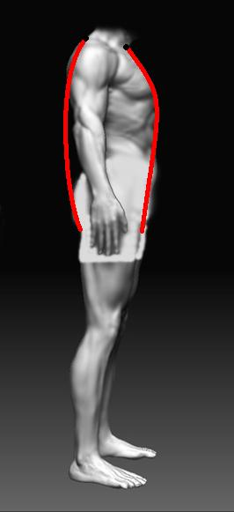

17 - Neck to Neck
Measure from the indent at the bottom
of your neck at the front, down through
your legs and up your back to the bone at
the base of your spine.

153cm

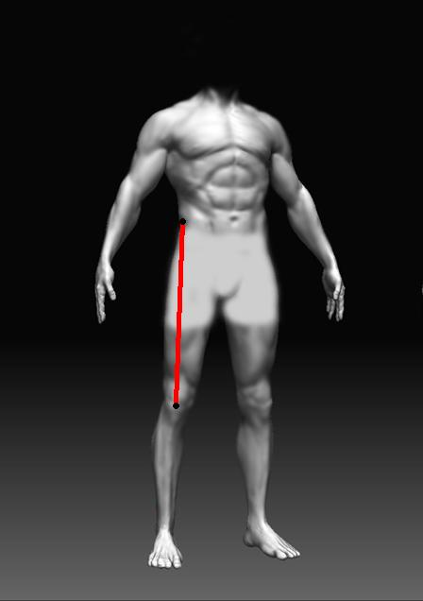
18 - Waist to Knee
Measure from the top of your hip bone
Usually Just above your trousers/pants
(waist belt line) to the centre of your knee cap
Keep your knee slightly bent.

54cm

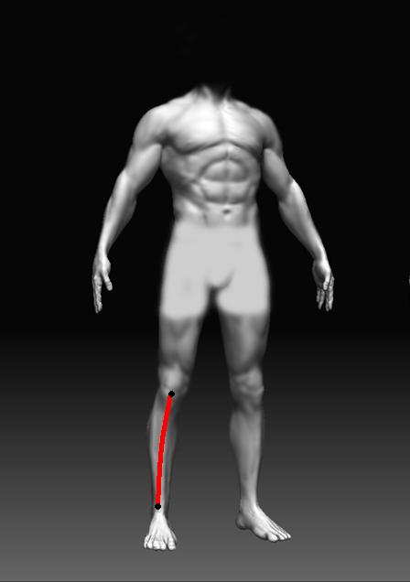
19 - Knee to Ankle
Measure from the centre of your knee cap
to your ankle (same point as outside and inside
leg)
Measurements 18 + 19 should add up to 14
outside leg figure, if they do not, please
re-measure
42cm

20 - Upper Thigh
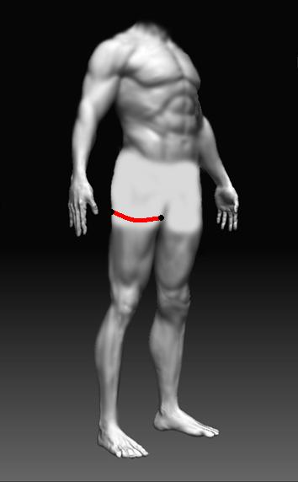
Measure loosely all the way around the top
of your thigh.

56cm

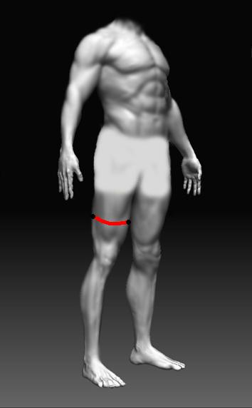
21 - Lower Thigh
Measure loosely all the way around the lower
part of your thigh.

42cm

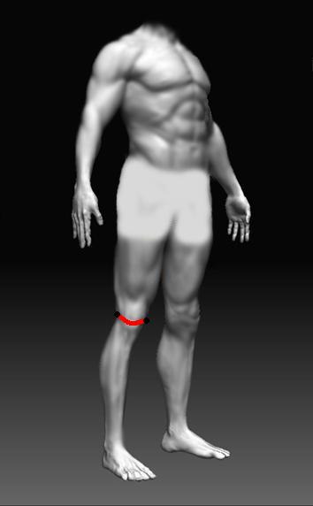
22 - Knee
Measure loosely all the way around your knee
While bent

41cm

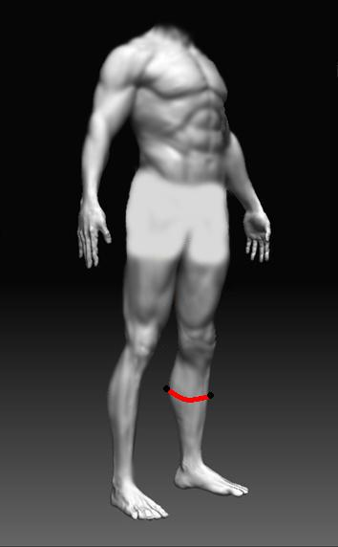

23 - Calf
Measure loosely all the way around your
Calf at the widest point

37.5cm

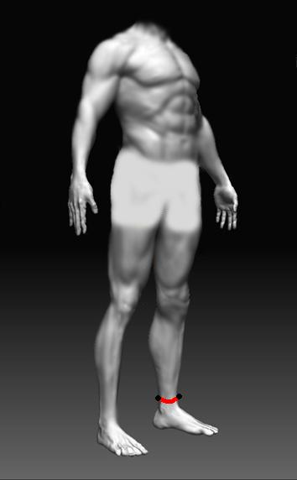

24 - Ankle
Measure loosely all the way around your ankle

22cm

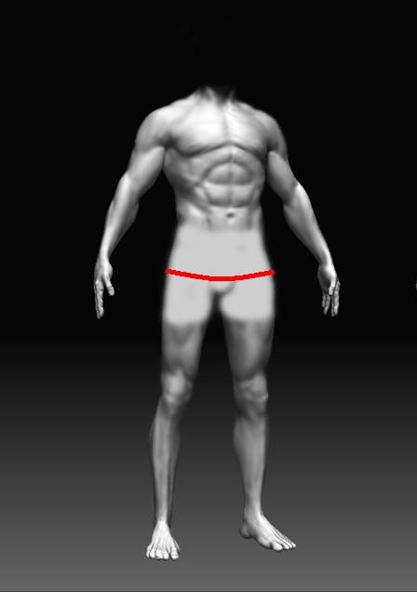

25 - Seat
Measure loosely all the way around your backside
at the widest point (around the front to back)

98cm

Height :- 175 Cms
Weight :- 68 Kgs

Suit Order:-

Customer Name:-
Customer Email:-
Customer Phone:-

Comments:-

